Template for preparing a memorandum for submission to *Optica*



**Memorandum**

Author One,1 Author Two,1 and Author Three2,*

1Publications Department, OSA—The Optical Society, 2010 Massachusetts Avenue N.W., Washington, D.C. 20036

2College of Physics, Jilin University, Changchun 130012, China

*Corresponding author: [author_three@uni-jena.de](mailto:author_three@uni-jena.de)

Received XX Month XXXX; revised XX Month, XXXX; accepted XX Month XXXX; posted XX Month XXXX (Doc. ID XXXXX); published XX Month XXXX

This template can be used to prepare a memorandum for submission to OSA’s journal for high-impact research, *Optica*. Memoranda have a two-page limit, and this template will help authors approximate final page length. Citations should use an abbreviated format (as described below), and formal funding sources should be identified separately from any other acknowledgments. Consult the [OSA Author Style Guide](http://www.opticsinfobase.org/submit/style/jrnls_style.cfm) for general information about manuscript preparation. © 2015 Optical Society of America

**OCIS codes:** (140.3490) Lasers, distributed-feedback; (060.2420) Fibers, polarization-maintaining; (060.3735) Fiber Bragg gratings; (060.2370) Fiber optics sensors.

http://dx.doi.org/10.1364/optica.99.099999

To use this template, you will need to apply the embedded styles to each paragraph-level item in your manuscript, or simply use this template as a visual guide.

USING THE WORD STYLES

In this template, styles such as “01 Title” for the manuscript appear in the MS Word Styles ribbon (or toolbar for older versions of Word). Apply the appropriate style before typing or apply the style to existing text. It is possible to paste manuscript text into this template or attach this template to an existing manuscript.

EQUATIONS

Display equations should be broken and aligned for one-column display unless spanning across two columns is essential. For MathType math, use the Format Equations feature to format all equations as Times + Symbol 10. Apply the Equations style to create appropriate spacing above and below.

 (1)

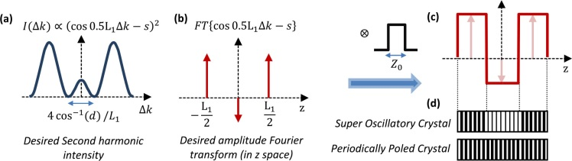

Fig. 1. Caption text with descriptions of (a), (b), and (c).

TABLES

Styles for table title, table head, and table text are provided in the MS Word Styles ribbon. Tables should be set as one column wide if possible and be placed near their first mention in the body.

FIGURES

As with tables and equations, figures should be set as one column wide if possible unless two-column display is essential. The figures should be accurately sized (a maximum of 3.5 inches wide for one column, 7 inches for two), and the caption should be added by right-clicking on the image and choosing Insert Caption. Then the figure and its caption can be selected and dropped into the template.

Removed supplemental material info.

FUNDING SOURCES AND ACKNOWLEDGMENTS

Formal funding sources should be listed in a separate paragraph block before any other acknowledgment information. Funding sources and any associated grant numbers should match the information entered into the Prism manuscript system. Funders should be listed without any introductory language or use of labels (do not use labels such as “grant no.”). Please note that headings should not be used for the funding information or the acknowledgment. Here is an example:

**Funding.** National Science Foundation (NSF) (1263236, 0968895, 1102301); The 863 Program (2013AA014402).

**Acknowledgment**. We thank Dr. Smith for his help with the experiment.

Removed supplemental material info.

REFERENCES

Set references at the back of the manuscript. *Optica*’s memoranda use an abbreviated reference style. Citations to journal articles should omit the article title and final page number. However, full references (to aid the editor and reviewers) must be included as well on a third page that will not count against page length. Please use blue for reference callout numbers in text to make the callouts more visible for peer review staff.

REFERENCES

1. M. R. E. Lamont, Y. Okawachi, and A. L. Gaeta, Opt. Lett. **38,** 3478 (2013).
2. A. Cordero-Davila, J. R. Kantun-Montiel, and J. Gonzalez-Garcia, in Imaging

and Applied Optics Technical Digest 2012 (Optical Society of America, 2012), p. 13.