Title of primary manuscript: supplementary material



**Supplementary Material**

Author One,1 Author Two,1 Author Three,2,*

1Publications Department, OSA—The Optical Society, 2010 Massachusetts Avenue N.W., Washington, D.C. 20036

2College of Physics, Jilin University, Changchun 130012, China

*Corresponding author: [author_three@uni-jena.de](mailto:author_three@uni-jena.de)

Published XX Month XXXX

This template can be used to prepare a supplementary document for inclusion with submission to OSA’s new journal, *Optica*. This document, which may include supplementary information such as expanded descriptions of materials and methods, will be published as a PDF linked to the primary article. The supplemental file should only present information that would be useful and worthwhile for the reader, for example, details that would be necessary to reproduce an experiment. The article, however, must be coherent without the supplemental PDF file. Please see the Author Guidelines for Supplementary Materials for more information. Supplementary documents are not copyedited and so should be prepared carefully with the template provided. An abstract outlining the methods and materials in the supplementary document should be included here. The primary article should also be identified in the abstract: This document provides supplementary information to “Title of primary manuscript,” *Optica* volume, first page (year). The supplementary document should also be referred to at the end of the primary article before the references: “See [Supplement 1](http://www.opticsinfobase.org) for supporting content.” OSA production staff will add final citation details, and so the source Word file must be provided. © 2014 Optical Society of America

[http://dx.doi.org/10.1364/optica.99.099999.s1](http://dx.doi.org/10.1364/optica.99.099999.s1%20) [supplementary document doi]

To use this template, you will need to apply the embedded styles to each paragraph-level item in your manuscript, or simply use this template as a visual guide.

Using the Word styles. In this template, styles such as “01 Title” for the manuscript appear in the MS Word Styles ribbon (or toolbar for older versions of Word). Apply the appropriate style before typing or apply the style to existing text. It is possible to paste manuscript text into this template or attach this template to an existing manuscript.

Numbering Items in the Supplementary Document. The supplementary materials document may contain additional figures, tables, equations, etc. Such items should be numbered, with an uppercase “S” to identify them as supplementary. For example, number the first figure in the supplementary document “Fig. S1”; the first table “Table S1”; etc.

Naming Convention for Countable Items

Algorithm S1

Equation (S1)

Figure S1

Media S1

Table S1

Equations. Display equations should be broken and aligned for two-column display unless spanning across two columns is essential. For MathType math, use the Format Equations feature to format all equations as Times + Symbol 10. Apply the Equations style to create appropriate spacing above and below.

 (S1)

Tables. Styles for table title, table head, and table text are provided in the MS Word Styles ribbon. Tables should be set as one column wide if possible and be placed near their first mention in the body.

Figures. As with tables and equations, figures should be set as one column wide if possible unless two-column display is essential. To ease manuscript preparation, figures can either be placed at the back or be set in the desired position within the text.

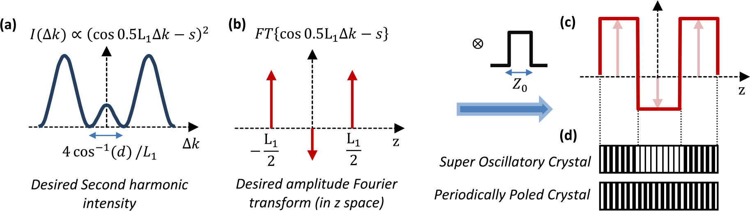

Fig. S1. Caption text with descriptions of (a), (b), and (c)..

Media. The supplemental document may contain linked objects such as video, 2D, 3D, and machine-readable data files. Please see the Author Guidelines for Supplementary Materials for more information. Such files should be cited in the supplementary document as in the primary document but using the naming convention described above.

References. The supplementary materials document may contain a reference list. The reference list should follow OSA's citation style and should be checked carefully, since no copyediting will be performed by OSA staff.

Citations that are relevant to the primary manuscript and the supplementary document may be included in both places.

References

1. M. R. E. Lamont, Y. Okawachi, and A. L. Gaeta, "Route to stabilized ultrabroadband microresonator-based frequency combs," Opt. Lett. **38,** 3478-3481 (2013)
2. A. Cordero-Davila, J. R. Kantun-Montiel, and J. Gonzalez-Garcia, in *Imaging and Applied Optics Technical Digest 2012* (Optical Society of America, 2012), p. 13.